C++ History

In 1979, Bjarne Stroustrup, while doing work for his thesis, used the programming language Simula, which was the first language to support object-oriented programming. Inspired and wanting more, he created “C with Classes,” which was a superset of the C language. He wanted to add object-oriented programming to C, including classes, inheritance, inlining, and default function arguments. In 1983, “C with Classes” was changed to C++.

C++ is a general-purpose programming language, but is used primarily for system programming, software, and applications, including video games, servers, databases, and space probes.

Getting Started

I had some issues installing the language. I initially wanted to use VSCode, so I installed some build tools for that and attempted to use the compiler MinGW. Unfortunately, even after doing extensive research about the PATH and how to build C++, VSCode for some reason would not accept my pathing (I’ll figure it out eventually). After days of frustration, I downloaded the IDE Eclipse. Luckily, I could use MinGW with Eclipse. I was easily able to get it set up, and run my first Hello World.

Visual Studio (VSCode) is the primary IDE for C++, which is why I wanted to use it first. Other programming environments that people use for C++ are Eclipse (of course), Code:: Blocks, CLion, CodeLite, Apache NetBeans, Qt Creator, among others.

I’ve included sources below in the Works Cited that I used to set up C++ myself, to write this article, and to use in the future.

Running Code

To run a C++ program in Eclipse, you need to right click the project name in Project Explorer, select “Build Project.” Once it’s built, you right-click the project name in the Project Explorer and click “Run as.” Then, select “Local C/C++ Application.” Then, it runs!

To write comments, you simply use two forward slashes: //

Below is a screenshot of the IDE, with Hello World built and run.

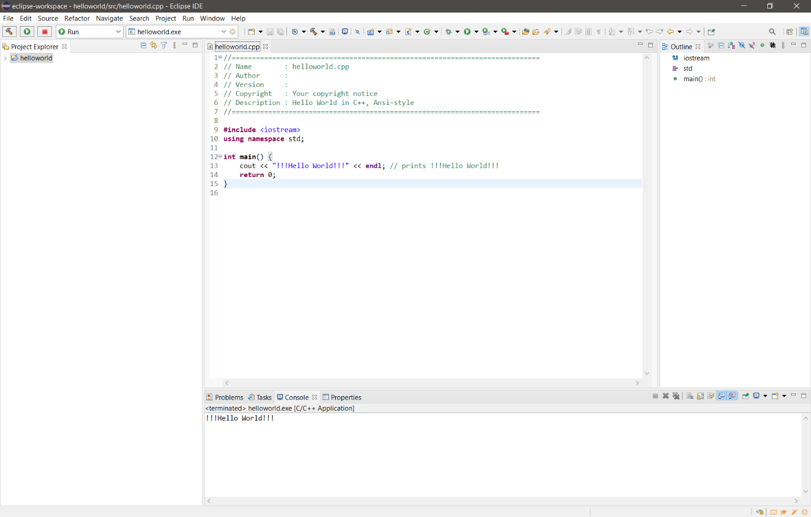

Works Cited:

“Eclipse for C++: How to Install, Setup and Use Eclipse For C++.” *Software Testing Help*, 27 Aug. 2021, www.softwaretestinghelp.com/eclipse-for-cpp/.

“Eclipse Platform.” *Help*, help.eclipse.org/latest/index.jsp.

“Overview.” *Mingw*, www.mingw-w64.org/.

*C++ Tutorial*, www.w3schools.com/cpp/default.asp.

Corob-Msft. “Microsoft C/C++ DOCUMENTATION.” *Microsoft C/C++ Documentation | Microsoft Docs*, docs.microsoft.com/en-us/cpp/?view=msvc-160.

“C++ Programming Language.” *DevDocs*, devdocs.io/cpp/.